This guide will review how a prescriber clinician can complete IDP/TFA flow through the LS platform. Please note that any user with the prescriber clinician role will be required to complete IDP. Only if the provider will be sending narcotics will the TFA be necessary. A valid DEA license is required to complete TFA.

Legal Agreements & Identity Proofing

- Access a client profile from med management (Can use a test patient for this process). User will get prompted right away to sign Dosespot agreements. This is required and cannot be skipped for user to move along the process.
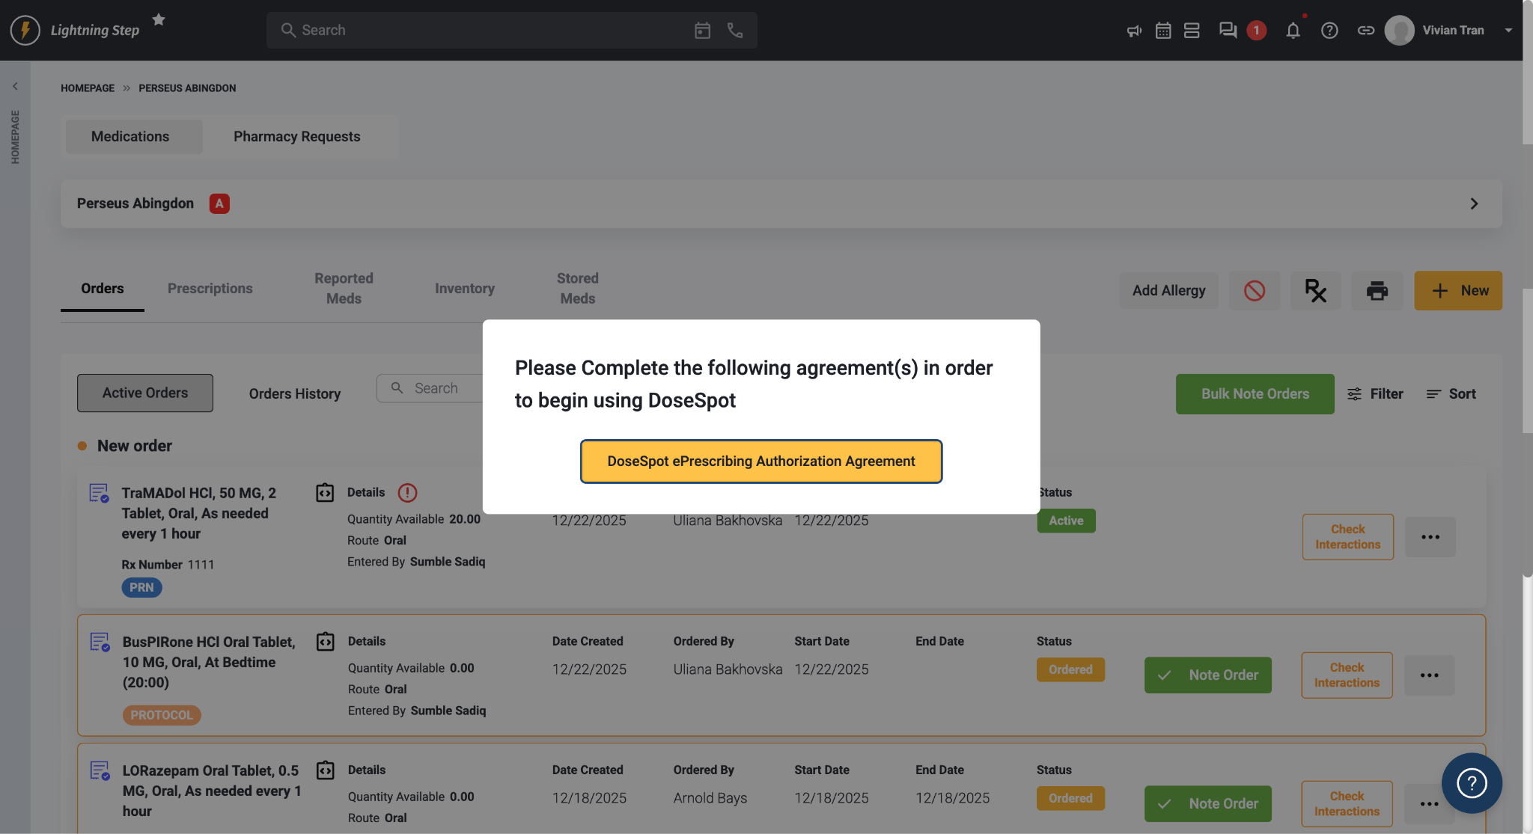

- Accept the agreements and click SAVE
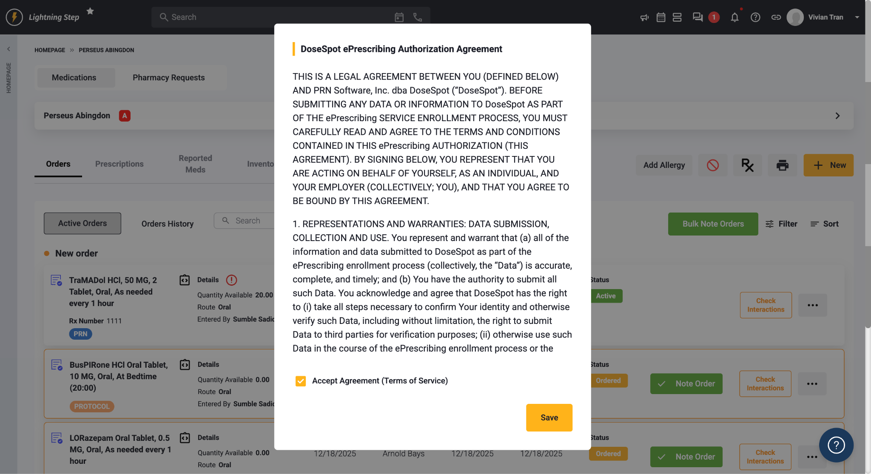

NOTE: If user is Proxy or Prescribing agent then process ends here. If user is Prescriber clinician then user will be prompted into the IDP flow after clicking SAVE.

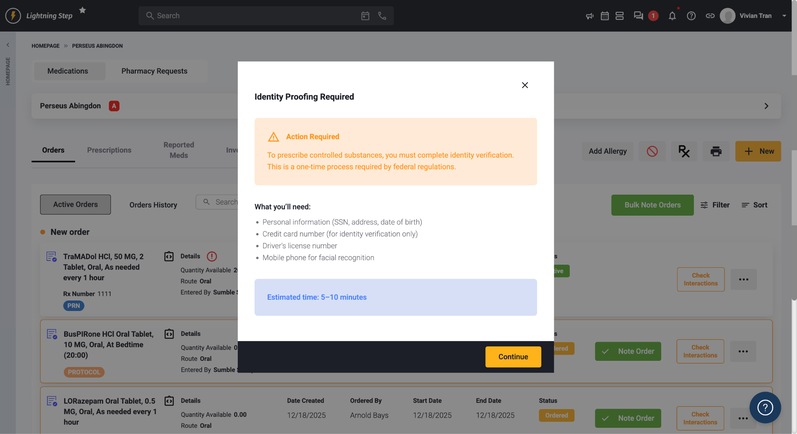

NOTE: It is recommended to complete this process all the way through. If the provider cannot do IDP at that time then it is ok to cancel out of the pop up, but please note that everytime user goes to med management page then the same prompt for DS legal agreements will occur.

- Accept the IDP Disclaimer
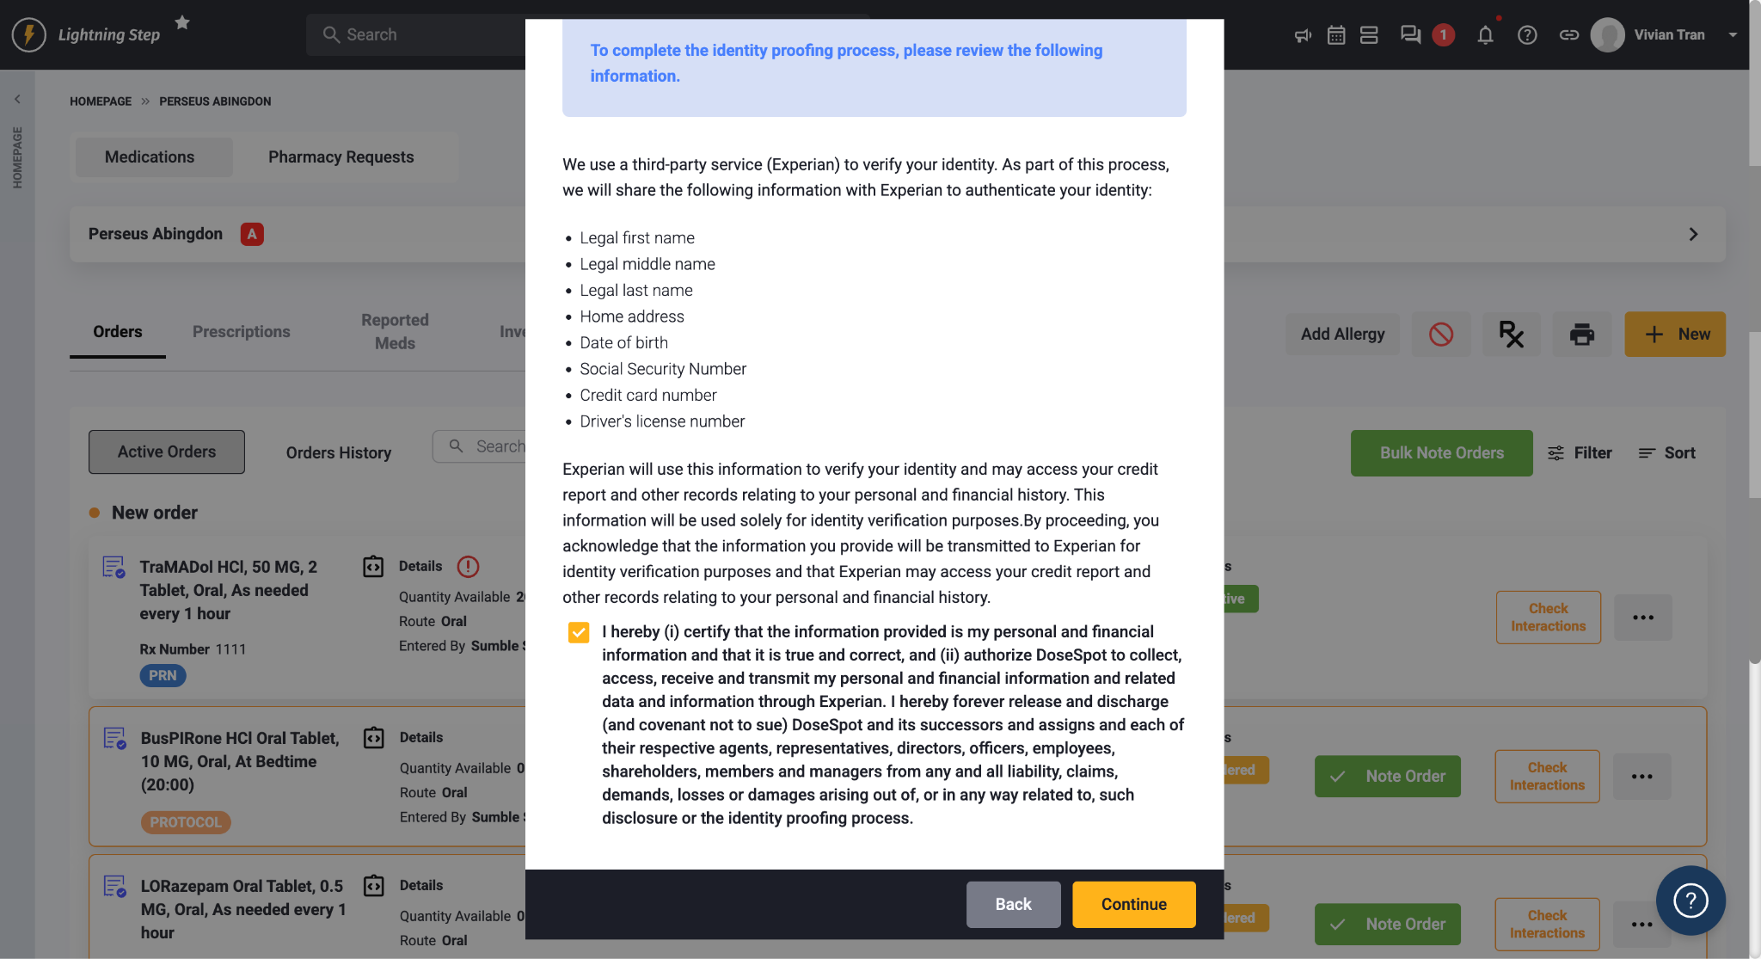

Note: The next steps will verify the provider identity through a soft credit pull with Experian. If provider had any recent changes to personal information such as address change or change in last name but did not update with credit bureaus yet, then should try with previous information first. LS does not have control over whether provider passes/fails IDP. If user fails 3x then please create a ticket with Dosespot. Also, provider needs to lift any freezes from their credit history before proceeding.

Required Fields: First Name, Last Name, Address, Mobile Number, SSN, and Credit Card Number (make sure no dashes are entered)

Happy Path (user passes the demographic information and will complete the set up on the phone. They will receive a text from experian and will need to have their ID ready to take a photo)
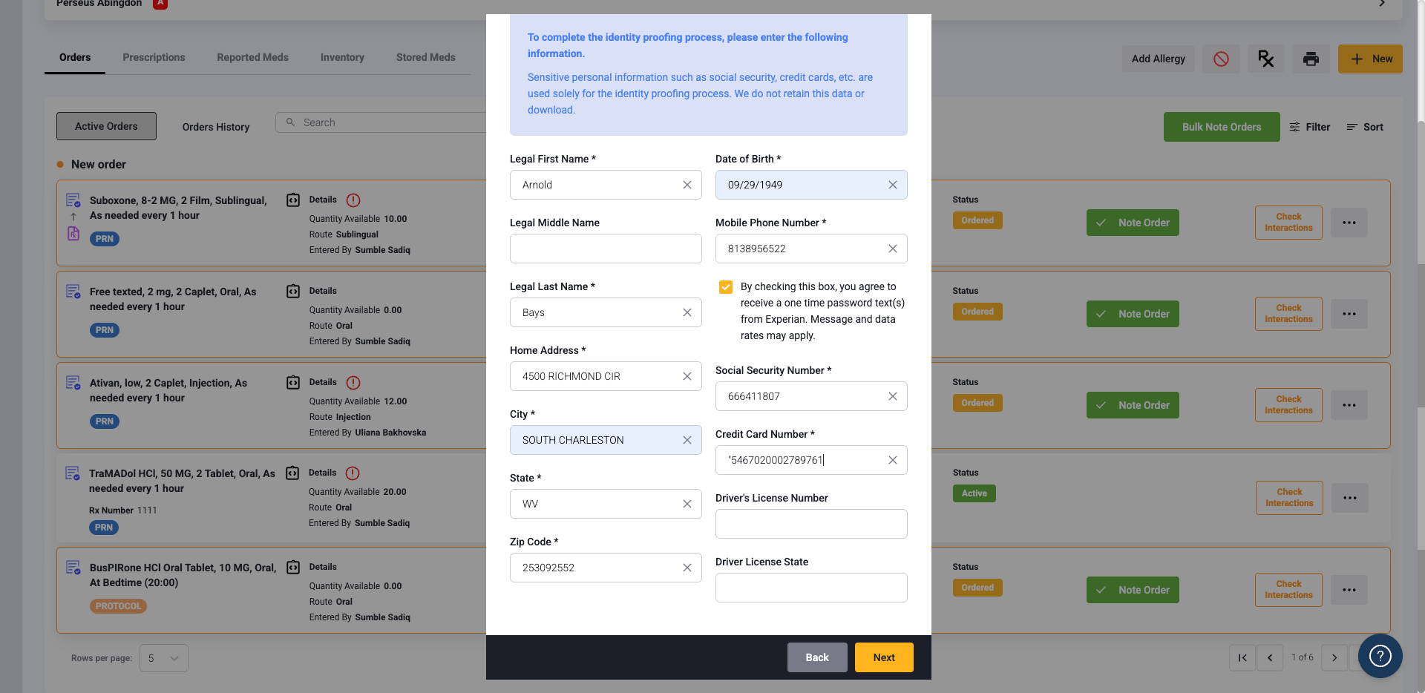

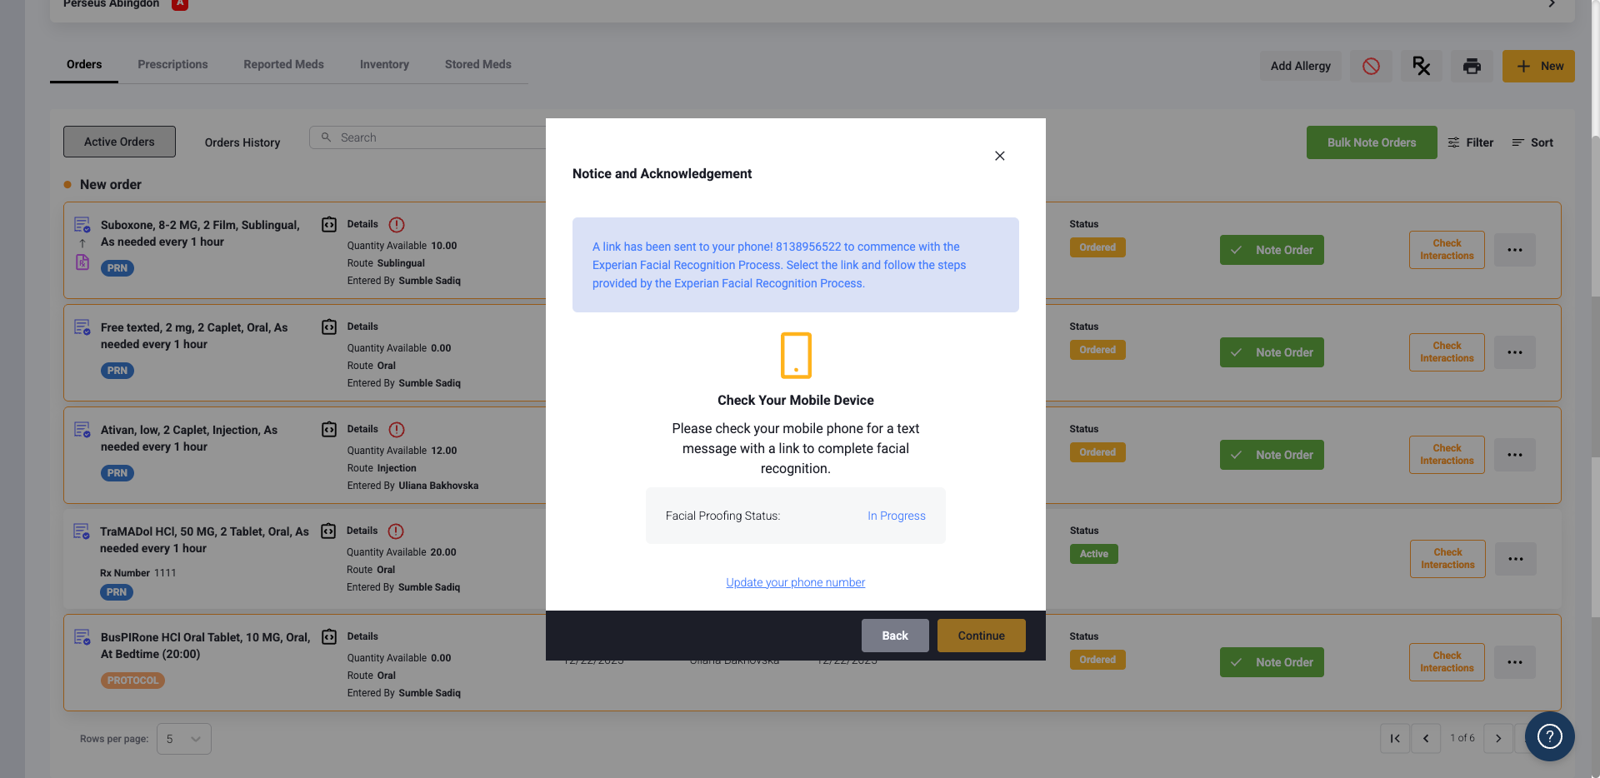

User finishes the set up on the phone once they get to this pop up. Once set up on phone is completed, wait a few moments for the pop up to update. Once updated they will see this “Identity Proofing Completed”

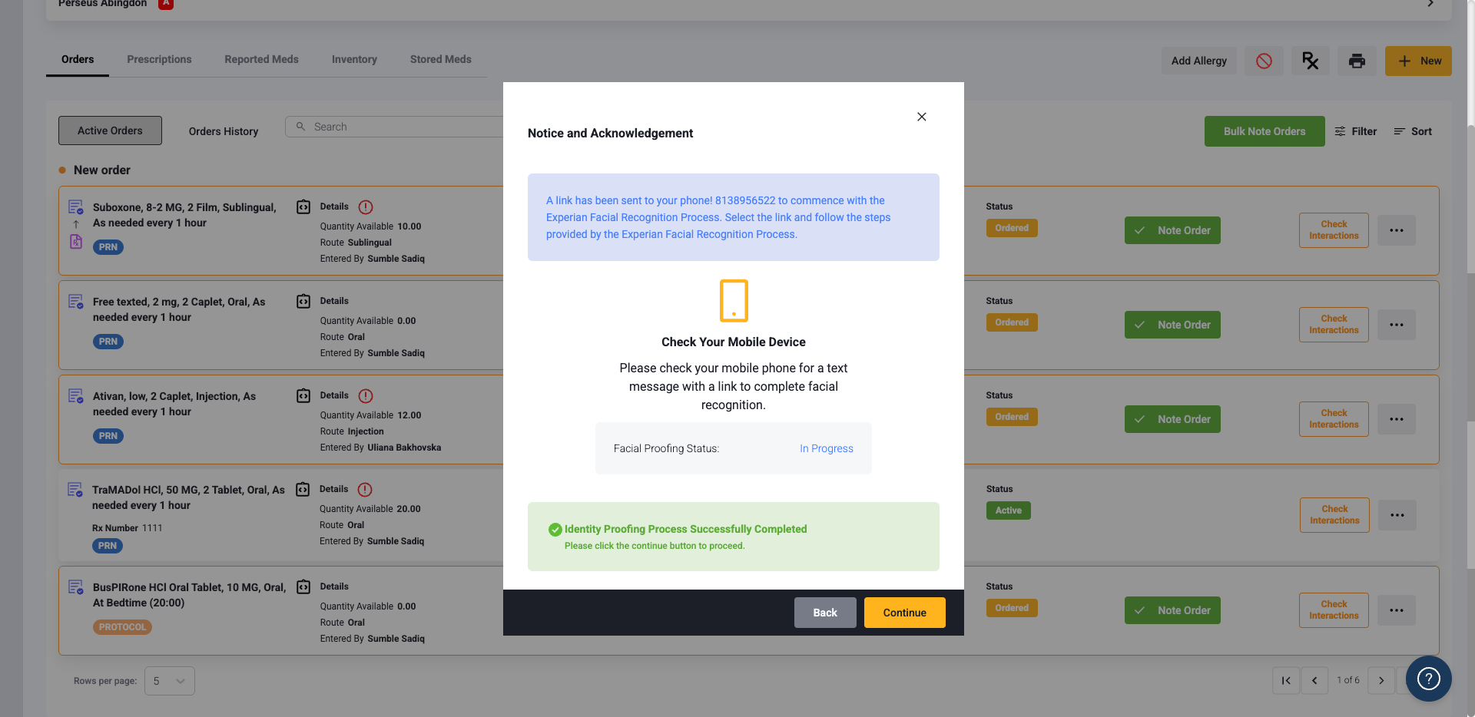

Unhappy Path:
User gets something wrong on demographics (like misspelling or wrong address) and is prompted with a set of questions. User has 3 tries with the questions until IDP is failed and Experian will mail a letter. Please reach out to Dosespot if this happens.

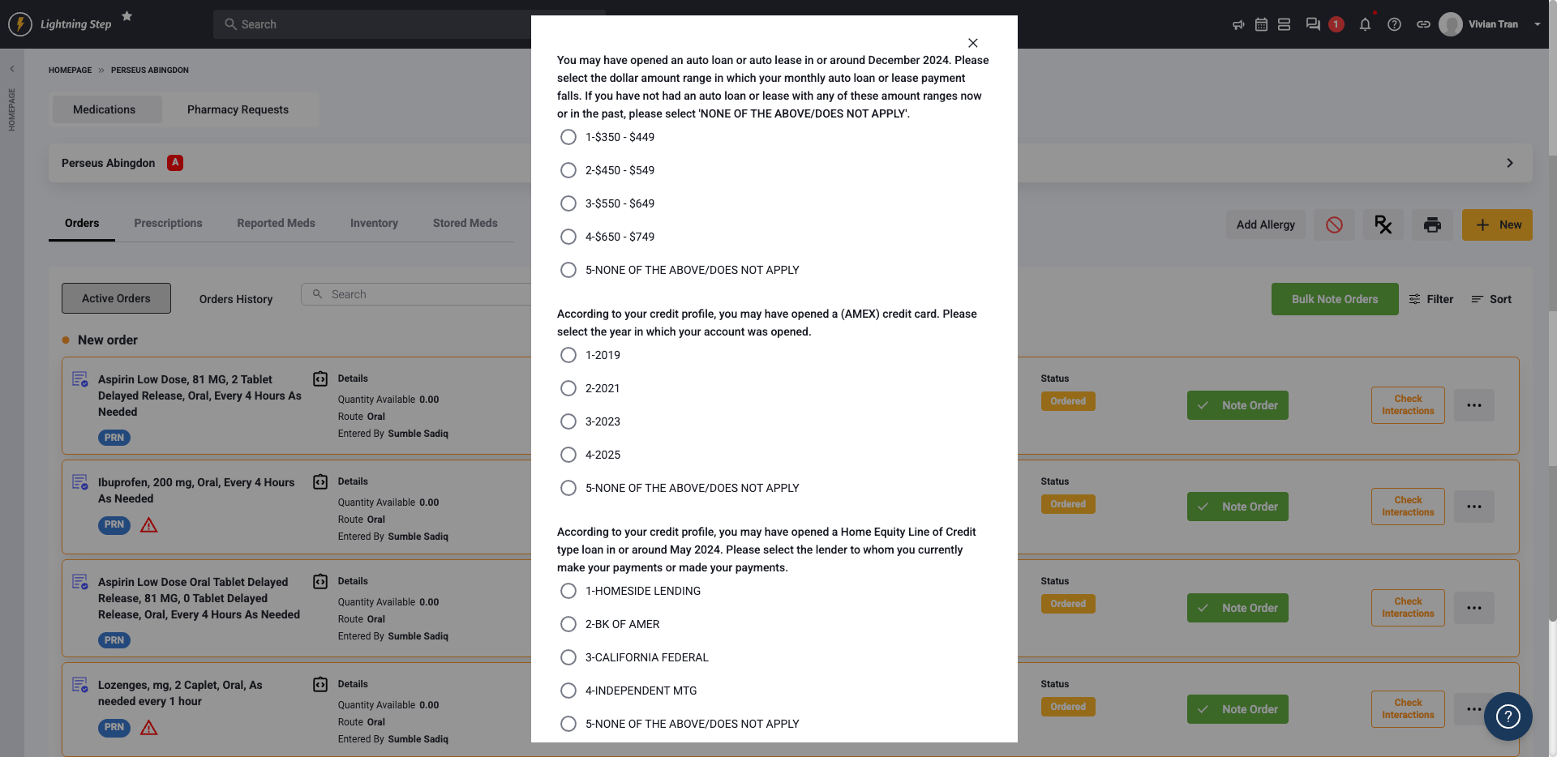

If user passes the questions, then the same prompt to complete Identity Verification on the user’s phone will take place.

If user has no DEA then the process will end here
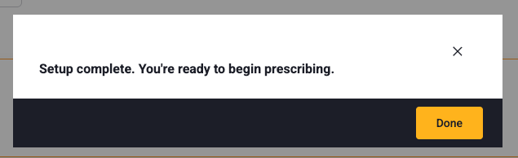

If user has a DEA license then the next steps will take place for TFA

How to complete TFA as a clinician:

Note: There needs to be a user at the clinic who is set up as “EPCS Coordinator” in the dosespot admin console and in LS user admin platform before proceeding with the following steps. This can be anyone at the clinic that is chosen by the customer, it is required for this user to “initiate TFA” for the clinician.

There are 2 ways that the provider can get prompted for the TFA flow

- If the provider is already set up from the beginning with DEA then right after IDP is done, TFA will be the next prompt. Recommended to set this up in the same flow, but if for some reason that can’t happen then the user can go back to prescriptions page at any point to resume TFA
This is what it will looks like when user is prompted right after IDP
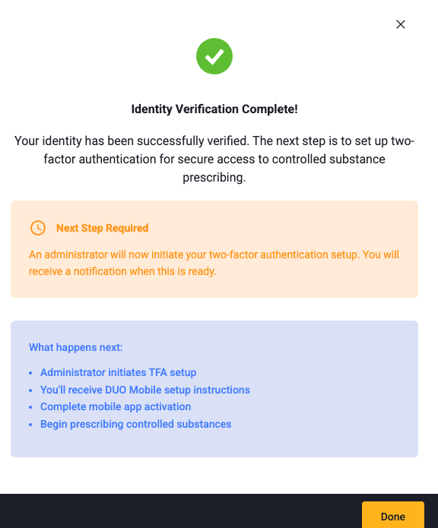
- If DEA is added at a later time (after the provider was already created, this could happen if provider is waiting for the license). The DEA first needs to be added in the DS admin console or in LS user admin and once this is done, then there will be a TFA icon the user will see on prescriptions page in med management.

Initiate TFA
- User will click the icon and if the user is not an EPCS coordinator then there is prompt to select the admin from a dropdown list.
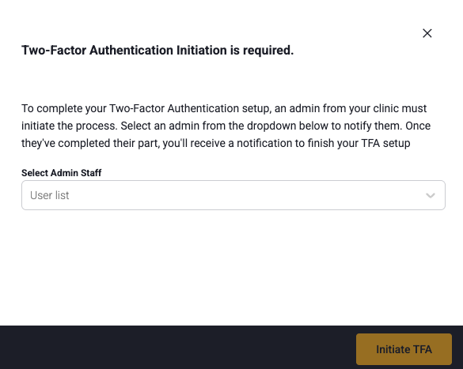
- User must select a staff person then click “initiate tfa” this will then send a notification to the person who was selected
- EPCS coordinator will receive a notification in their inbox
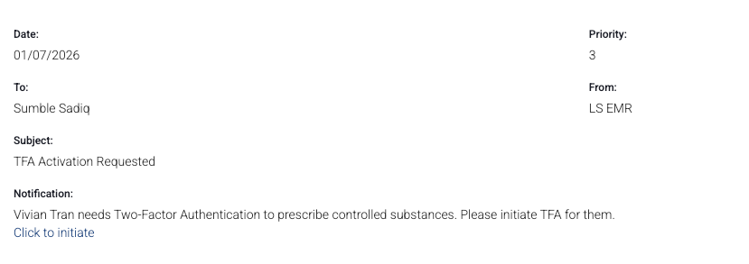
- EPCS coordinator needs to click to initiate, then a success message will occur
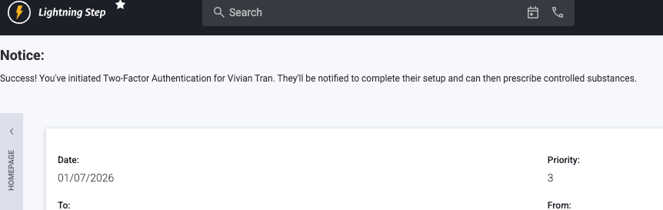

- Clinician then gets this notification once ready
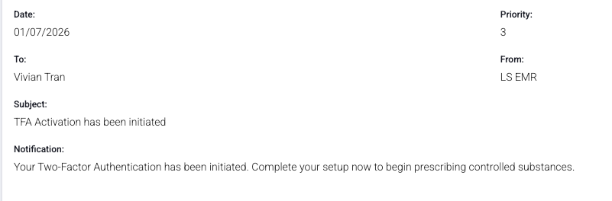

- Clinician will go back to prescriptions tab in med management to proceed.
Enter mobile phone number
User will be prompted to download DUO and will be given a TFA

Other option is the provider is the EPCS coordinator too so can initiate their own TFA and will see this:

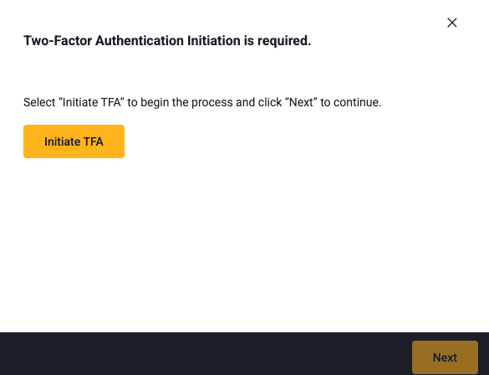

After that then the provider will follow the same TFA activation steps.
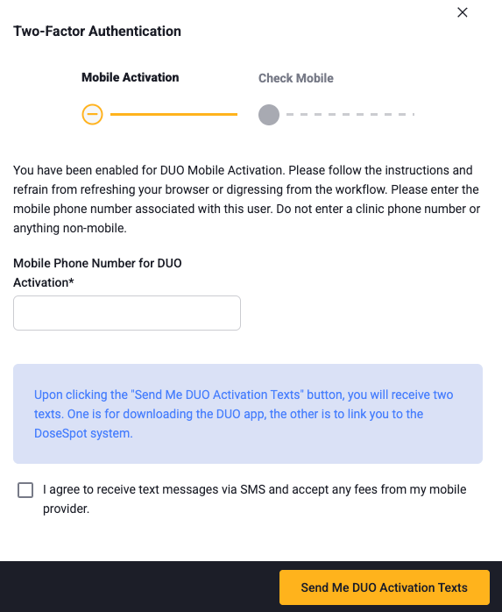

- User will enter TFA code from the Duo app and their pin. If they don’t have a pin yet then there is a place that says “click here” where user is redirected to the page to create a pin then can come back
